SQL Exercise – [SQL Playground (cockroachlabs.com)](https://www.cockroachlabs.com/docs/tutorials/sql-playground.html)

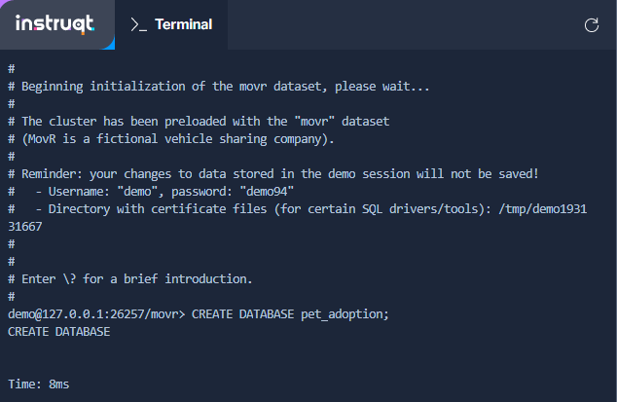

Creating a database named pet_adoption.

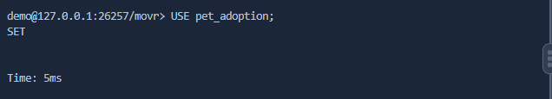

Makind the database the current “Active” one with the command use.

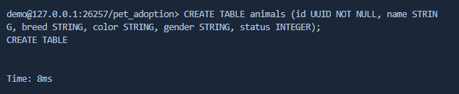

Creating a table in the DB pet_adoption in which during insert the parameter UUID must be provided, with the rest of the available parameters to be inserted in the fields (columns) being name, breed, color, gender and status which are all type String and can be empty.

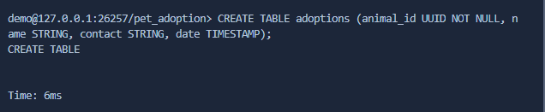

Creating a table in the DB pet_adoption in which during insert the parameter UUID must be provided with the rest of the available parameters to be inserted for the rows (records) being name, contact – type string and date – type TIMESTAMP which stores date and time value - if the table was created with the folloing it would have had a “default” date inserted if the field was left empty which can be useful ( date TIMESTAMP DEFAULT CURRENT_TIMESTAMP )

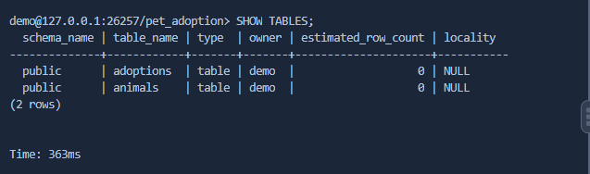

Lists all of the tables as a table ( each table is a row )

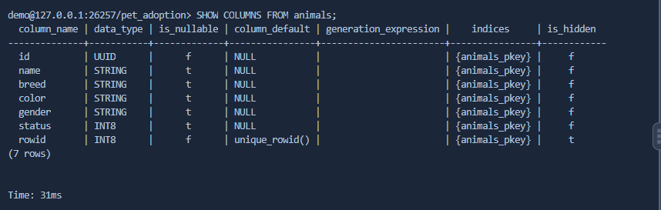

Lists all of the columns from the table animals as rows in a table with information provided about the fields themselves.

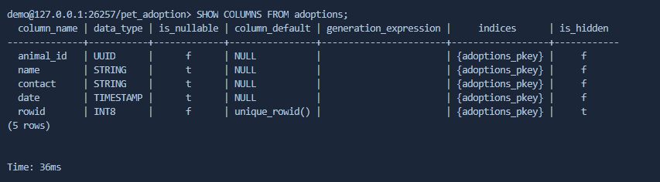

Lists all of the columns from the table animals as rows in a table with information provided about the fields themselves.

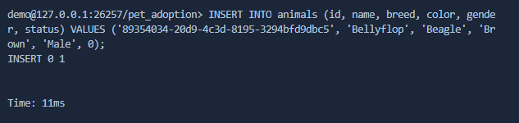

Inserts value into the table animals and effectively fills out one row of the cable, meaning there is 1 value in each respective column (for the one dog being accepted into our shelter) id=provided UUID, name=Bellyflop, breed=Beagle, color=Brown, gender=Male, Status=0.

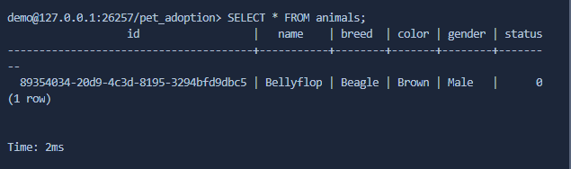

Lists the whole table with all rows,columns – in this case only lists the values for the 1 dog we have entered information for.

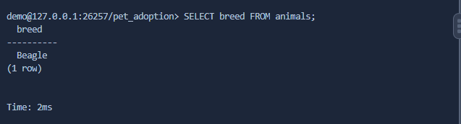

Lists the value for breed for all dogs in the table animals – again in this case only lists the values for the 1 dog we have entered information for.

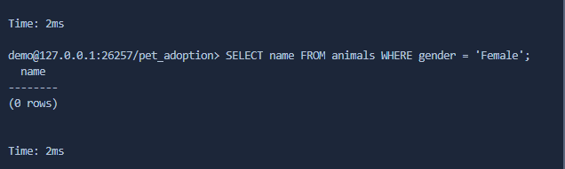

Lists the names of all dogs which have the value Female for the field gender in the table animals –in this case does not output anything because we have inserted info about only 1 dog which is male in this case.

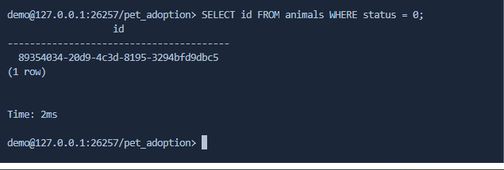

Lists the id (UUID) for all dogs which have the value 0 for status from the table animals – again in this case only lists the values for the 1 dog we have entered information for as it has status value = 0.